CE211-L Circuit Analysis Lab



Lab Report # 10

Submitted By:
Shayan Rizwan Yazdanie [2024585]
Syed Zain Ali Shah ]2024623]
Muhammad Abdullah [2024318]
Submitted to: Engr. Muhammad Shakaib
Semester: 03

Faculty of Computer Science and Engineering
GIK Institute of Engineering Sciences and Technology

Task Statement:
1. Calculate the current (I_{N}) and resistance (R_{th}) in the given circuit.
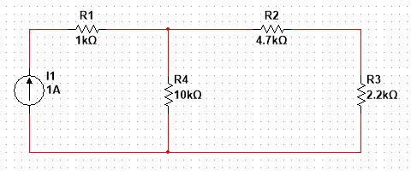

Solution
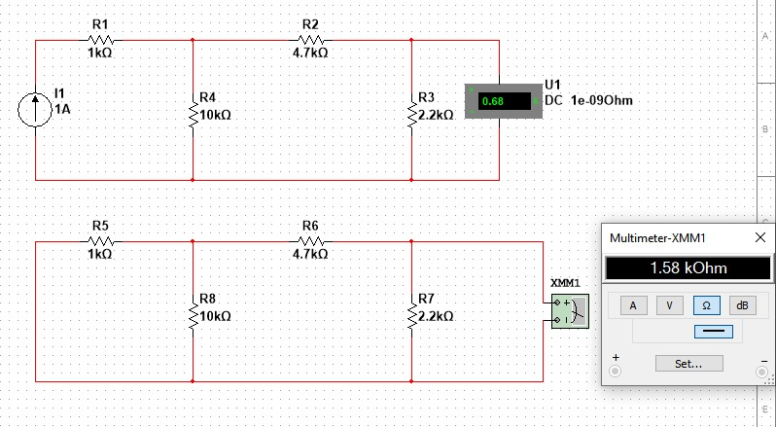

Apply Mesh Analysis:
I₁ = 1A
KVL on Loop 2:
10k(I_{2 –} I₁) + 4.7k(I₂) + 2.2k(I₂ – I₃) = 0
-10k I₁ + 16.9k I₂ – 2.2k I₃ = 0
16.9k I₂ – 2.2k I₃ = 10k – (1)
KVL on Loop 3:
2.2k (I₃ – I₂) = 0
2.2k I₃ – 2.2k I₂ = 0 – (2)
I₂ = 0.68 A
I₃ = 0.68 A
I_{N} = I₃ = 0.68 A
R1k || 10k = 0.90 kΩ
R_{series} = 5.6 kΩ
R5.6_{k || 2.2k} = 1.58 kΩ
I_{N} = 0.68 A
R_{TH} = 1.58 kΩ

